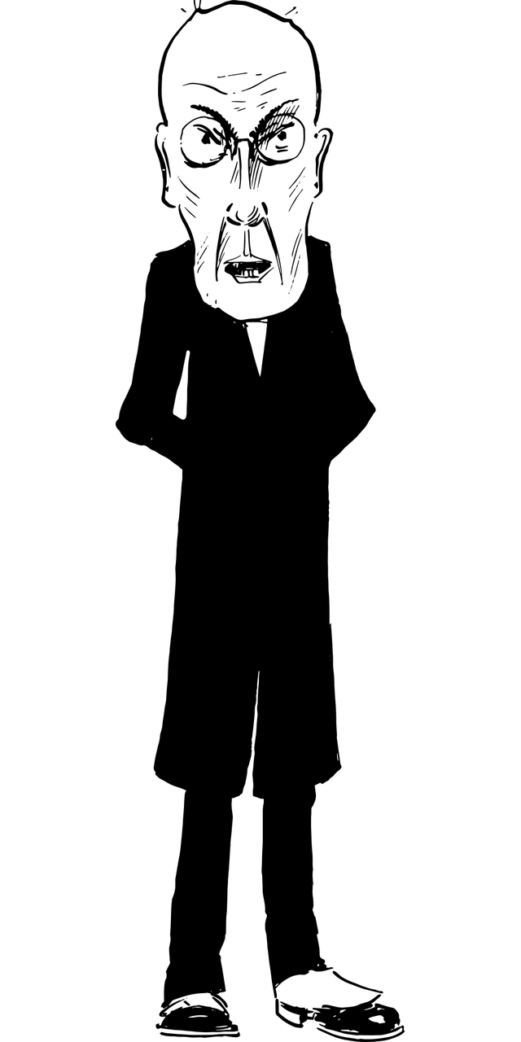
PERSON (Character)

Stick or draw a picture of your character here:

What is interesting about your character?
Why would someone want to read about them?
Write down as much as you can about your character.
What makes them unique?

Name
Age
What do they look like/wear?

Job

Catchphrases /Common Words

Likes/Hobbies

Dislikes

Who is their family?

Good points

Bad points

Sense of Humour

Favourite Foods

Irritating Habits

Ambition

Anything Else (Secret)

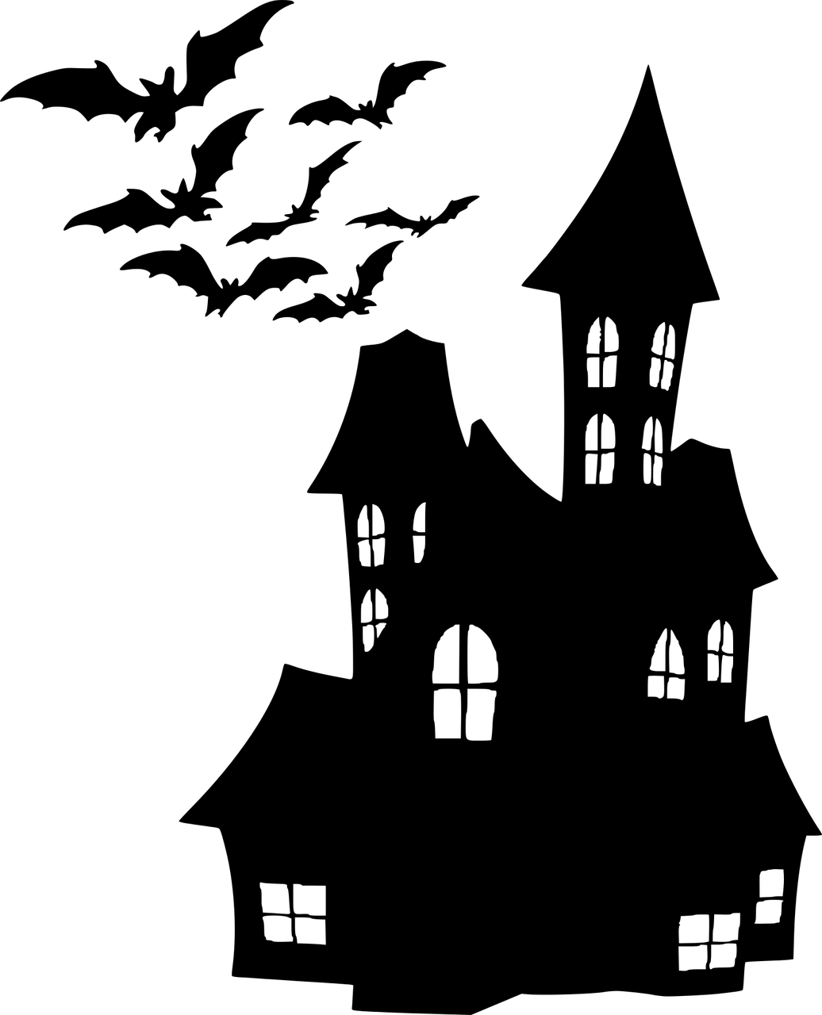
PLACE (Setting)

Stick or draw a picture of your setting here:

Your setting is vital to your character and plot.
Think about how your character(s) will live/work/have an adventure here.

Be as detailed as possible about where the action and your character are going to be.

Name of place

Country/Land

What does the scenery look like?

Smells

Sounds

Sights

Who else is there?

What is unusual?

Why is your character there?

Anything else we need to know?

PLOT (The Story)

Use this W-Graph to plot your story, its highs and lows and the end

Consider:

- What starts your character on their journey / Where does the action begin?
- What are the main obstacles your character has to overcome?
- How do they change as a result of what happens to them?
- Just when they think they are succeeding/surviving/beating evil, what else can happen to them?
- Tie up the loose ends/answer any questions you’ve posed

Plot Your Story

Title

Inciting Event

1st Plot Point

2nd Plot Point

3rd Plot Point

High Point

Rug Pulling Moment

Climax

Resolution

Writing Beginnings

Look at the first few lines of May's Moon:

"Click. Michael May fastened the last strap on his spacesuit and lifted on his helmet.

‘Primary life support system secure?’ shouted the bald-headed man in front of him.

‘Check!’

‘Helmet secure?’

‘Check!’

‘Suit sealer secure?’

‘Check!’

Michael looked around the hangar. Forget Tom Hill’s dream of driving a Bugatti Veyron.

Forget Darren Fletcher fantasizing about playing left wing for Chelsea. This had to beat

the whole lot: for the first time in his life, Michael wished that everyone at home could

see him.

‘Give me a thumbs up y’all when you’re ready,’ said the bald-headed man in uniform.

‘Then I’ll start up the pumps. Any problems just put your hand up and we’ll stop.’

As the words still echoed, Michael’s legs wobbled underneath him. What if he wasn’t

any good? What if he messed it up? This wasn’t just a dream any more. He really was in

America and he really was just about to find out what it felt like to float in space."

- What do you think is happening?
- What do you learn about Michael?
- What are his characteristics?

Exercise:

Think of an exciting opening to your story and write it down.
Think of your descriptions, imagery, dialogue and action.

------------------------------------------------------------------------------------------------------------------------------------------------------------------------------------------------------------------------------------------------------------------------------------------------------------------------------------------------------------------------------------------------------------------------------------------------------------------------------------------------------------------------------------------------------------------------------------------------------------------------------------------------------------------------------------------------------------------------------------------------------------------------------------------------------------------------------------------------------------------------------------------------------------------------------------------------------------------------------------------------------------------------------------------------------------------------------------------------------------------------------------------------------------------------------------------------------------------------------------------------------------------------------------------------------------------------------------------------------------------------------------------------------------------------------------------------------------------------------------------------------------------------------------------------------------------------------------------------------------------------------------------------------------------------------------------------------------------------------------------------------------------------------------------------------------------------------------------------------------------------------------------------------------------------------------------------------------------------------------------------------------------------------------------------------------------------------------------------------------------------------------------------------------------------------------------------------------------------------------------------------------------------------------------------------------------------------------------------------------------------------------------------------------------------------------------------------------------------------------------------------------------------------------------------------------------------------------------------------------------------------------------------------------------------------------------------------------------------------------------------------------------------------------------------------------------------------------------------------------------------------------------------------------------------------------------------------------------------------------------------------------------------------------------------------------------------------------------------------------------------------------------------------------------------------------------------------------------------------------------------------------------------------------------------------------------------------------------------------------------------------------------------------------------------------------------------------------------------------------------------------------------------------------------------------------------------------------------------------------------------------------------------------------------------------------------------

