**Author KS2 Workshop**

Dear Parents,

On 2nd October author Sue Palmer will be running a KS2 workshop for our year xx children at Sample Primary School, called ' Secrets of the Shore – Rocking rock pools'. Sue will be reading from her new children's book, *The Shell Secret*, an adventure and mystery story, set on the Cornish coast, and will reveal the amazing and strange lives of some of the creatures to be found in our rock pool micro-habitats.

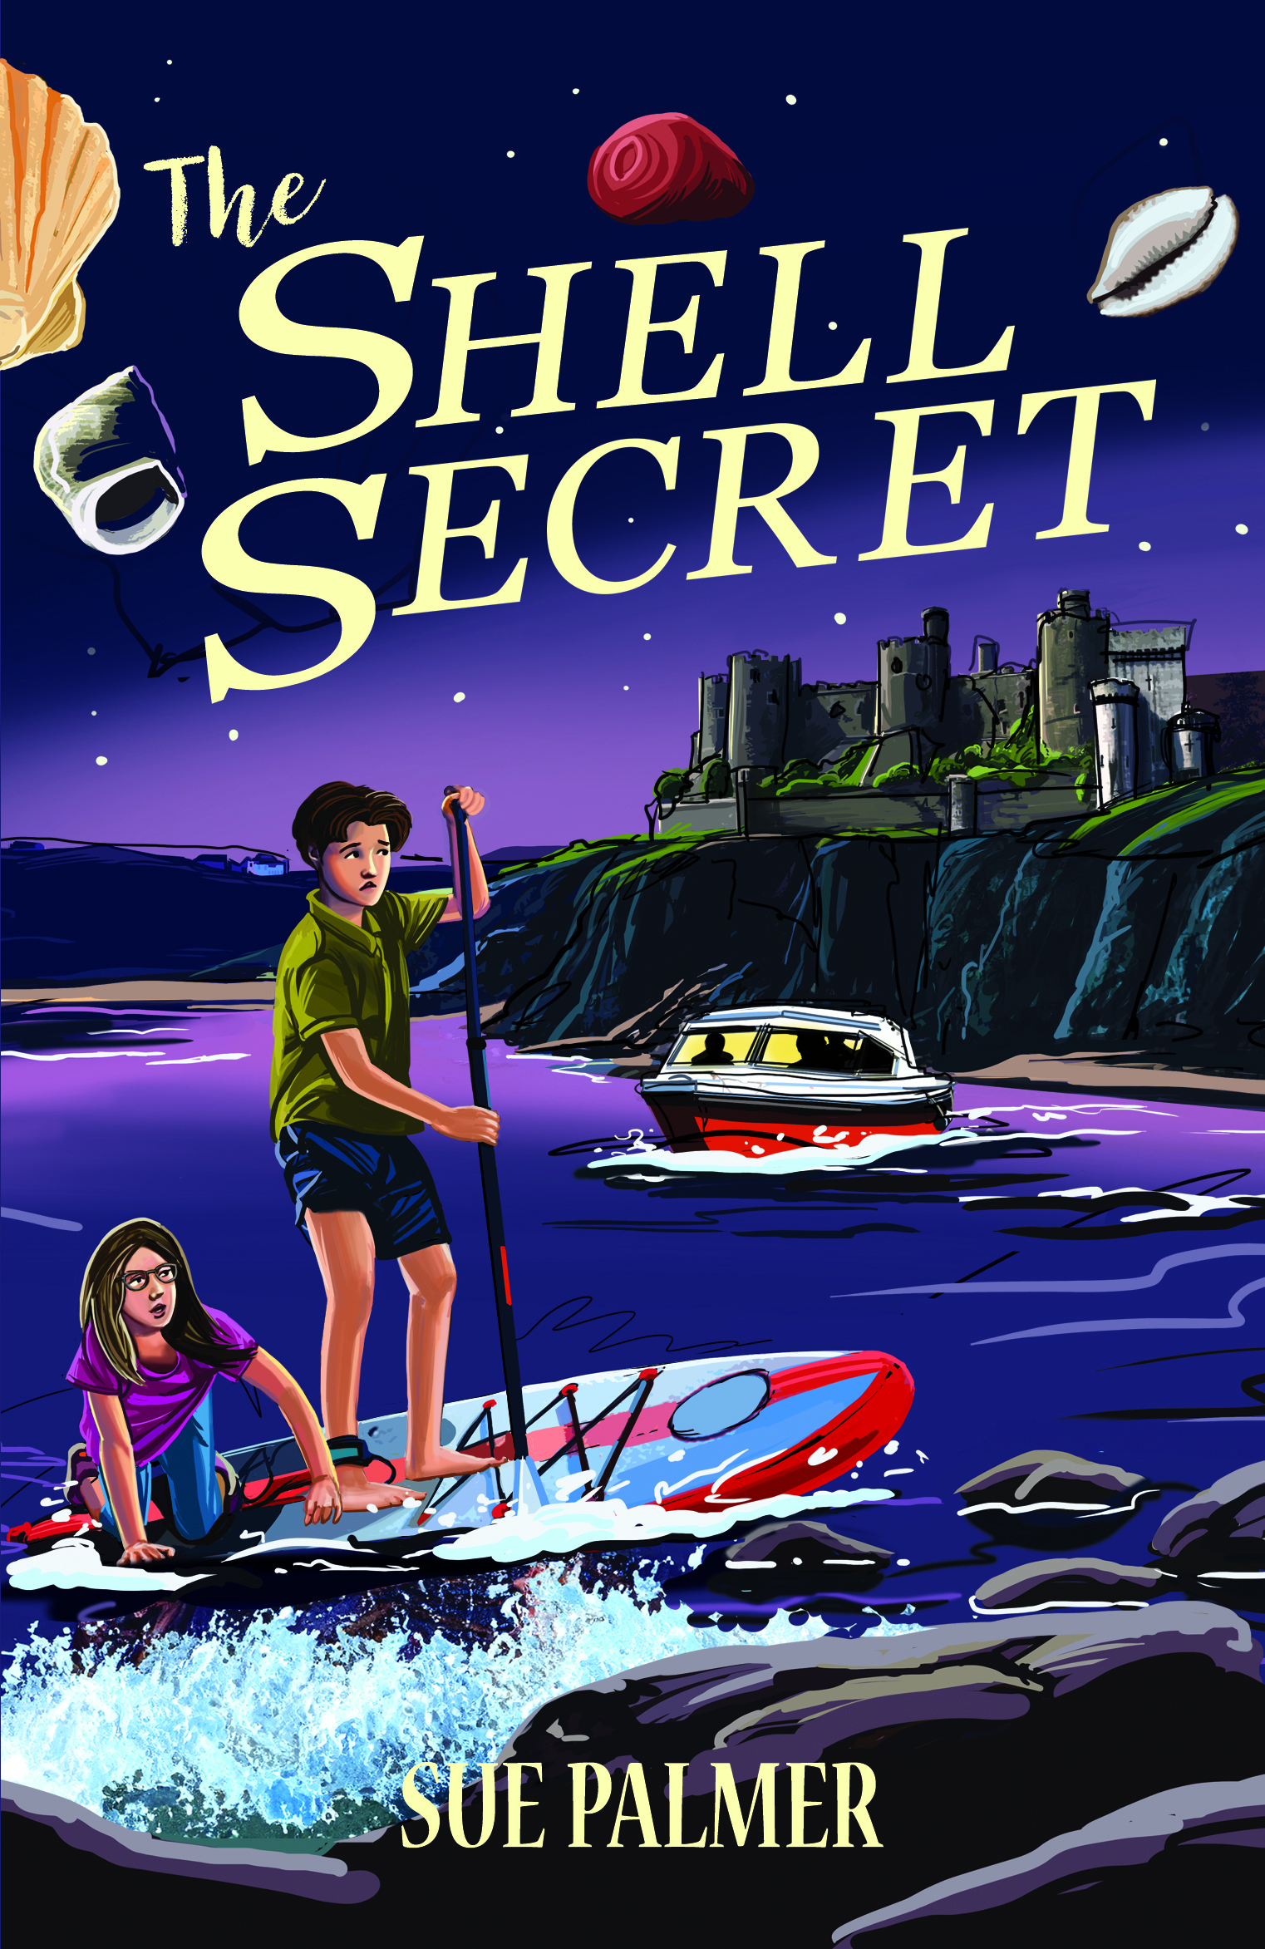

*For 11-year-old budding detective Alice Clark, summers in Trevellen used to mean roaming the beaches and rockpools, collecting shells with her sister, Poppy.*

*But this year is different. A year after Poppy’s death, Alice returns alone—determined to build a shell memorial in her honour, and desperate to ensure her sister is never, ever forgotten.*

*Forbidden from visiting the beach by herself, Alice reluctantly strikes a deal with Jasper—the annoying boy who’s just moved in next door.*

*But the arrangement quickly becomes more complicated than she expects.*

*Drawn into the heart of a sinister World War II mystery, Alice and Jasper find themselves in real danger, unearth a shocking family secret, and risk losing the one thing Alice came back to Trevellen to protect.*

If you would like your child to have a book signed by Sue or to order books for gifts, please complete and return this form with payment either by PayPal (ref: Sample Primary) or to your child’s teacher by 29th September. Sue will sign and personalize each book. Thank you.

Head/Class Teacher

✂- - - - - - - - - - - - - - - - - - - - - - - - - - - - - - - - - - - - - - - - - - - - - - - - - - - -

**Book Order**

Child’s Name (please print)_______________________________________

Child’s Teacher/Class _____________________________________­­­­­­­­­­­­­­­­­_______

**The Shell Secret x 1 book** @ £8.00 each = £_______

**The Shell Secret x 2 books** @ £14.00 = £_______

**Total: £ ________**